Task 1 flow chart

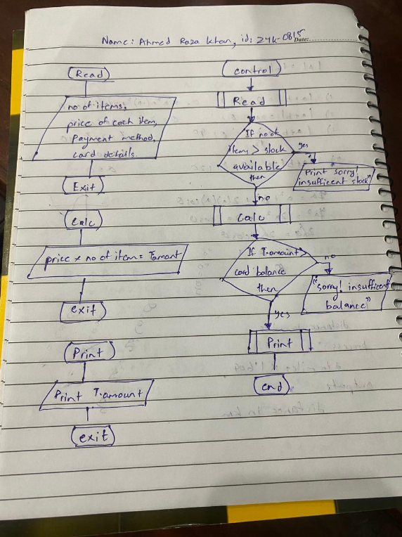

psuedocode

Lab task 1

Start

Input number

Set var to 0

Var 🡨 number / 5

If IsInteger(var) is true then

Print “Number is multiple of 5”

Else

Print “Number is not multiple of 5”

end

lab task 2

start

Input char

If Uppercase(char) is true then

Print “It is a uppercase char”

Else

Print “ It is a lowercase char”

end

lab task 3

start

input num1

input num2

input operator

if operator is “+” then

var 🡨 num1 + num2

else

var 🡨 num1 * num2

print var

end

lab task 4

start

input num

if num > 0 then

print “number is positive”

elseif num < 0 then

print “number is negative”

else

print “number is 0”

end

lab task 5

start

input age

if age > 12 and age < 20 then

print “ u are teenager”

else

print “u are not teenager”

end

# Algorithm

Lab task 1

Ask the user to enter year

Divide year by 4 and store in var1

If var1 is integer so divide year by 100 and store in var2

If var2 is not integer so divide year by 400 and store in var3

If var3 is integer then the year is leap year

Lab task 2

Input a string

Let input = A

Check repeated numbers from 0 to 9 and count

Display

Check repeated symbols and count

Display

Lab task 3

Input a number which contain power

Let the integer in that number be x

Let its power be y

Now multiply x with x same number of times power y is given

Display result

Lab task 4

Ask the user to input radius

Set area to 0

Set area to 3.14*radius^2

Display area

Lab task 5

Ask the user to input num1 num2 and num3

Set median to 0

Set min to 0

Set max to 0

if num1 < num2 set num1 to min else set num2 to min

if num3 < min then set num 3 to min

if num1 > num2 set num1 to max else set num2 to max

if num3 > max then set num 3 to max

set median to (num1 + num2 + num3 – min –max)

display median